10/17/2019
Country Report: Optimal Industry Development Strategy for Japan

Heyang Huang, Soulaymane Kachani, Lun Li, Jiayu Zhao Economic Complexity lab
Columbia University
Optimal Industry Development Strategy for Japan

0. Executive Summary

In this report, we aim to uncover the economic path Japan went through during the period from 2009 to 2014. Specifically, we dive into the topic through a macroeconomic overview of Japan from the perspective of Gross Domestic Product (GDP) and Economic Complexity Index (ECI), which reflect countries’ production capability and production structure, respectively. We find that during the period of our interest, Japan demonstrated a particularly low level of economic growth with an annual GDP growth rate of -1.5%, concurrent with a stagnation in economic complexity as compared with other major economies in Asia.

The lack of economic progress during the period, we believe, can be partially explained through analysis of the economic and product complexity structure of Japan on the industry group level. The product classification system we adopt allows us to measure the realized industry development for various industry groups and to observe that Japan aggressively invested in High-complexity Products, Machinery and Construction and transportation industry groups during the period, while its developed peers and emerging economies around the globe have adopted a slightly more conservative growth path.

Based on our analysis of the opportunity gain and a sensitivity analysis of major industry groups, Japan can further its gains by staying optimal with its current industry structure and there is no immediate need of reform because no industry has a positive opportunity gain at its current stage. We further note that Japan has a slightly mismatched development strategy that indicates a moderate level of structural optimality on the complexity level, having an adjusted R-square of around 58.3%. Since a significant positive correlation exists between five-year GDP growth and the structural optimality index of an economy as we define and calculate, Japan indeed has a suboptimal growth experience as compared with fast-growing economies both on a regional scale and on a global scale, and has the potential to further its economic gains through industrial structure balancing as suggested in the paper.

1. Report Overview

In this report, we aim to uncover the economic path Japan went through during the period from 2009 to 2014. Specifically, we dive into the topic through a macroeconomic overview of Japan from the perspective of Gross Domestic Product (GDP) and Economic Complexity Index (ECI), which reflect countries’ production capability and production structure, respectively. We then analyze the industrial framework and changes of Japan during the period based on quantitative measures such as Product Complexity Index (PCI) and Product Family Complexity Index (PfCI), followed by a detailed analysis of how such changes have matched with development strategies as quantitatively measured by opportunity gains on an industry-level. We conclude our report with macro-level results and predictions of Japan, as deduced from regression models we have established on a global scale, which take into account countries’ stances in their product space.

2. Macroeconomic Results

2.1 GDP Ranking and Changes
As the 3rd largest economy in the world by GDP, Japan has a GDP of 5.7 trillion USD in 2009 and 4.9 trillion USD in 2014, exhibiting an extraordinary level of economic output. Figure 1 illustrates the time-series GDP results for world’s leading economies from 1996-2016, and Japan ranks among its counterparts as a stable player. Japan exhibits a consistent level of economic growth during the twenty years from 1996 to 2016, but from 2009 to 2014, Japan has an annual GDP growth rate of -1.5%. This rate is clearly below the annual growth rate of the group of leading economies in the world, which have a geometric average growth rate of 5.1% and an arithmetic average growth rates of 5.2%. The annual growth rate of -1.5% is particularly in sharp contrast to an annual growth rate of 15.5% for China, one of Japan’s major competitors in the market. The stagnated economic growth in Japan, we believe, can be reflected through consistent ECI and PCI, and can be further explained by a mismatched set of production strategies Japan adopted during the period, which we will expand at the later stage of the report.

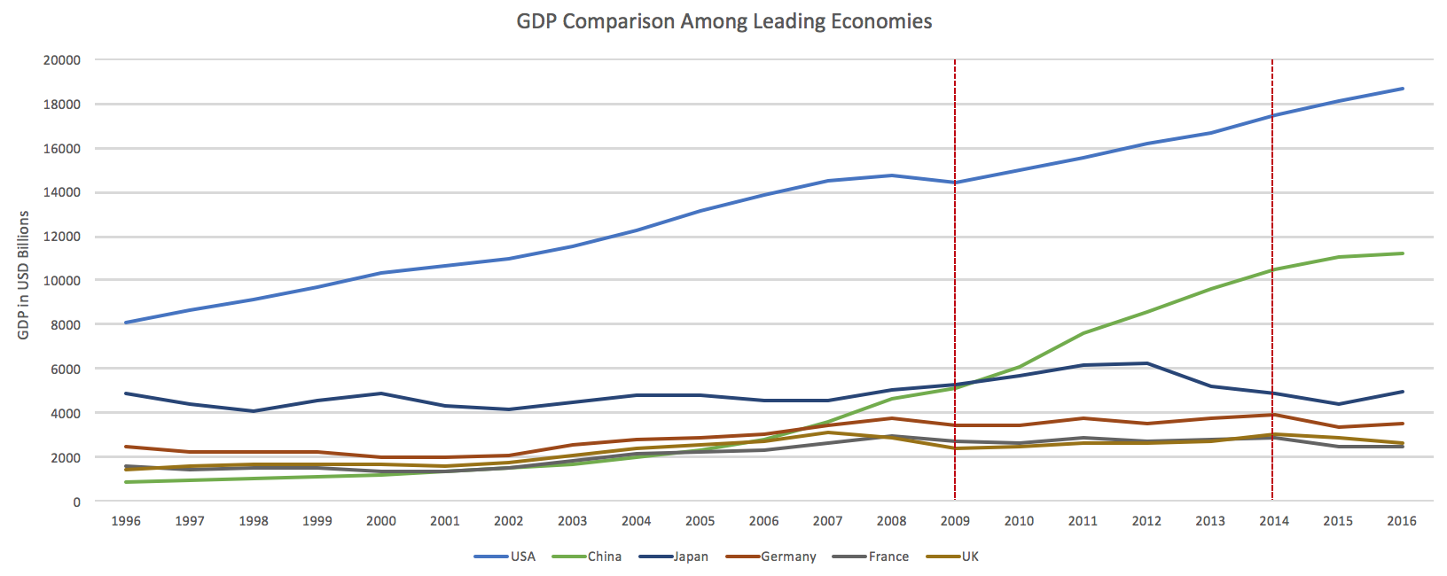

Figure 1: GDP Comparison Among Leading Economies

2.2 ECI Ranking and Changes
The Economic Complexity Index (ECI), as defined by Ricardo Hausmann and Cesar Hidalgo in 2009 to explain the knowledge accumulated in a country's population, exhibits similar pattern for Japan. As illustrated in Figure 2 below, Japan exhibits a stable but flat curve in terms of its production capability from 2009 to 2014, which is true for most of the developed economies. This is in direct contrast to countries such as China, which demonstrates overwhelming advantage over Japan in terms of both ECI and GDP growth during the period.

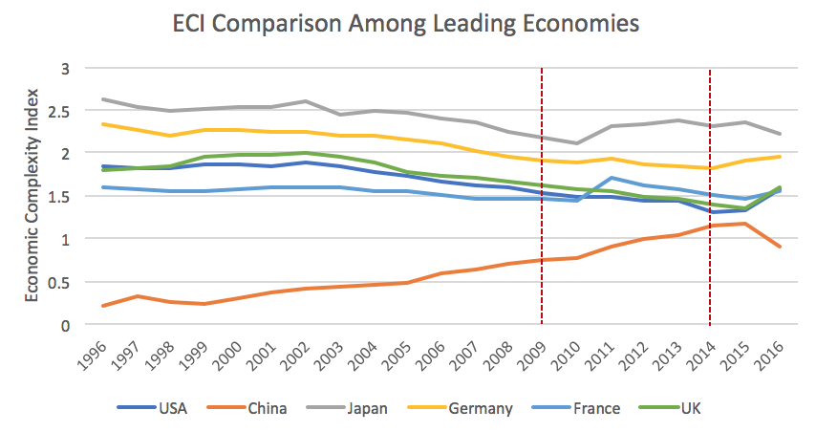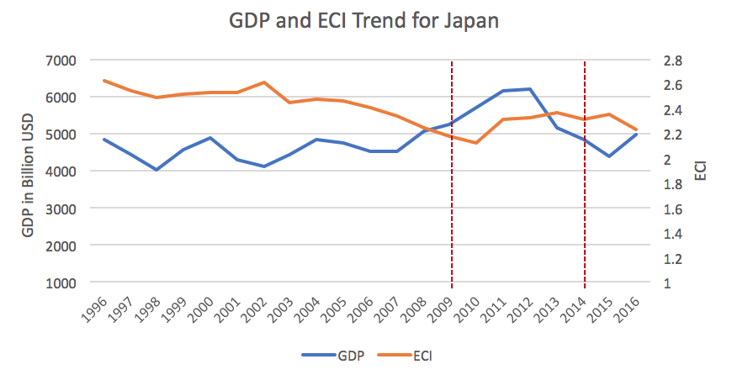

Figure 2: ECI Comparison Figure 3: GDP and ECI (Japan)

Figure 3 offers a further comparison of GDP and ECI over the entire time span from 1996 to 2016 for Japan. The stagnancy in GDP during the period from 2009 to 2014 is accompanied by a stagnancy in ECI, indicting the potential that the mild economic growth experienced by Japan during the period from 2009 to 2014 might be attributed to its slow-growing ECI, or the ineffectiveness of the country in developing a competitive product space that helps to accumulate complicated knowledge and technology. In order to provide a more concrete answer to why this has happened, we will dive into an analysis of Japan’s production structure and its product space designs in the next few chapters.

3. Production Analysis

3.1 Product Categorization
Our main data source in this research is the UN Comtrade Website (https://comtrade.un.org), which provides us with valuable information on countries’ export values on an annual basis, including highly specific export data for more than 5000 categories of products. In order to have a holistic vision of the product space of a country, however, a level of categorization is required. Product in our data source are labelled from 010000-999999, with the first two-digits representing a general category to which the product belongs. Based on the 99 categories as extracted from the label, we further group the products into 18 most widely-accepted industries, as summarized in Table 1.

Note that the High-complexity Products industry group is not a distinct industry but rather an aggregated industry that encompasses the most complicated products from the most technologically-advanced industries (as measured by PCI). This industry serves as an indicator for us to quantitatively evaluate how well a country has performed in developing cutting-edge technologies and closing its technical gap with advanced economies, which has become a topic of wide concern today. Indeed, when we rank the 18 categories based on PfCI (an equivalent concept of PCI as calculated based on the 18 categorized product groups), High-complexity Products industry has the highest PfCI among all industry groups.

Category | Description
Animals and By-products | All kinds of meat, livestock and related by-products
Vegetables, Fruits and Plants | All kinds of plants, edible vegetables and fruits
Food and Preparations | Edible preparations, raw cooking materials and appliances
Clothing and Accessories | All kinds of fabrics, filament, clothing and accessories
Textiles | All kinds of textile articles and related products
Wood Products | Book, paper and other elementary products related to wood
Metals | Mining of all sorts of raw Metals
Refined and Processed Stones | Refined or processed stone products such as pearl and ceramics
Energy Drilling and Mining | Mining industry for energy, minerals, stone materials, etc.
Daily Instruments | Basic daily instruments such as sport requisites, timing and measuring tools
Raw Manufacturing | Basic products made from plastic, rubber, leather, etc.
Chemical Manufacturing | Advanced chemical products and pharmaceutical products
Chemicals | Raw chemical materials and by-products
Machinery and Construction | Machinery and mechanical appliances, including electrical equipment
Transportation | Vehicles and locomotives including aircraft, ship, railway, etc.
Weapons | Explosives, arms and ammunition
Services and Utilities | Financial, business, legal, communication, travel Services and Utilities, etc.
High-complexity Products | Agglomeration of advanced products with highest PCIs

Table 1: Categorization of Products

We further observe a strong positive correlation between the GDP and the export of High-complexity Products. As shown by Figure 4 below, a high adjusted R-square of 67.6% exists between GDP and High-complexity Products exports, indicating that more successful economics, as measure by GDP, tend to be those that are capable of producing and exporting High-complexity Products as we define them.

Statistics | Value
Multiple R | 0.824
R-Square | 0.679
Adjusted R² | 0.676
Variable | Value
Coefficient | 12.20
t-stat | 15.61
P-value | 0(***)


Figure 4: Regression of GDP and High-complexity Products Exports

3.2 Realized Industry Development
Based on the product categorization aforementioned, we aim to capture Japan’s realized industry production strategy between 2009 and 2014 on a complexity level. In Hausmann and Hidalgo (2009), distance is defined to be a measure of how far a country is from a certain product not in its product space. We extend this concept to all product groups and quantify how technically equipped a country is to develop the corresponding product groups. In other words, the shorter the distance between a country and a product group, the more capable a country is in developing products within that group. Defining this net distance change as the Realized Industry Development (RID), our export data allow us to calculate and compare RID of Japan and the 18 product groups in 2009 and 2014 through subtraction, where a positive RID indicates a shortening of the distance (i.e., advancement of the industry), and a negative RID indicates the reverse. As ranked in Table 2, during the period from 2009 to 2014, Japan has focused on products with a high level of complexity and those requiring advanced skills, including High-complexity Products, Machinery and Construction and transportation, as is unusual among Asian economies.

Category | RID | Category | RID
1. High-complexity Products | 0.115 | 2. Machinery and Construction | 0.103
3. Transportation | 0.090 | 4. Energy Drilling and Mining | 0.087
5. Weapons | 0.087 | 6. Food and Preparations | 0.074
7. Wood Products | 0.067 | 8. Services and Utilities | 0.067
9. Vegetables, Fruits and Plants | 0.065 | 10. Metals | 0.062
11. Chemicals | 0.060 | 12. Clothing and Accessories | 0.059
13. Textiles | 0.044 | 14. Refined and Processed Stones | 0.043
15. Animals and By-products | 0.040 | 16. Chemical Manufacturing | 0.016
17. Daily Instruments | 0.015 | 18. Raw Manufacturing | -0.001

Table 2: Realized Industry Development (RID) of Japan

3.3 Regional and Global Comparison
Table 3 and 4 below summarize how the production strategy adopted by Japan compares with its Asian counterparts and a selected group of leading economies in the world, as measured in RID. It can be directly observed that Japan focused on products with a higher complexity level, when compared against its Asian counterparts such as China and India, which gave a considerable level of attention to more basic product groups such as Refined and Processed Stones and Daily Instruments.

Ranking | Japan | China | Korea
1 | High-complexity Products | Refined and Processed Stones | Chemicals
2 | Machinery and Construction | Services and Utilities | Machinery and Construction
3 | Transportation | High-complexity Products | High-complexity Products
4 | Energy Drilling and Mining | Machinery and Construction | Weapons
5 | Weapons | Chemicals | Refined and Processed Stones

Table 3: RID Comparison on a Regional Scale

Ranking | The United States | Germany | France
1 | Services and Utilities | Chemicals | Raw Manufacturing
2 | Chemical Manufacturing | Services and Utilities | Energy Drilling and Mining
3 | Food and Preparations | High-complexity Products | Refined and Processed Stones
4 | Textiles | Transportation | Chemical Manufacturing
5 | Clothing and Accessories | Food and Prep | Chemicals

Table 4: RID Comparison on a Global Scale

Table 4 further examines Japan’s development strategy against those of more developed economies on a global scale. Reasonably, developed economics such as the United States, Germany, Singapore and Japan have devoted the majority of their efforts into highly complicated industry groups while emerging economies such as Japan still partially rely on basic industry groups like Energy Drilling and Mining. This trend holds true in general, regardless of the continent or the time period, and serves as an indicator for which phase of development a country is currently in as evaluated from its production strategy. Based on this standard, Japan is indeed adopting an advanced and ambitious strategy that seeks development in industry groups with a high level of complexity.

4. Product Space Design

4.1 Suggested Development Vector
As aforementioned, distance gives us an idea of how far each new product is from a country’s current mix of exports. As defined in Hausmann and Hidalgo (2009), distance is “the weighted proportion of products connected to goods p that country c is not exporting, i.e., MCP=0.” Based on this definition, the distance between a country and any product that the country is currently exporting (i.e., the country is a significant exporter in the product as compared to global average) is zero. Similarly, opportunity gain quantifies the contribution of a new product in term of opening up the doors to more and more complex products. Intuitively, a product that a country is currently exporting (i.e., MCP=1) has an opportunity gain of zero. And unreasonable investment on certain product p would lead to a relative decrement in export of more profitable products, and therefore lead to a negative opportunity gain of product p. The opportunity gain is not the only estimator of a country’s level of economic development. However, among countries with comparable economics strength, those having higher ECI, or in other words, more reasonable economics structure are often in better shape.

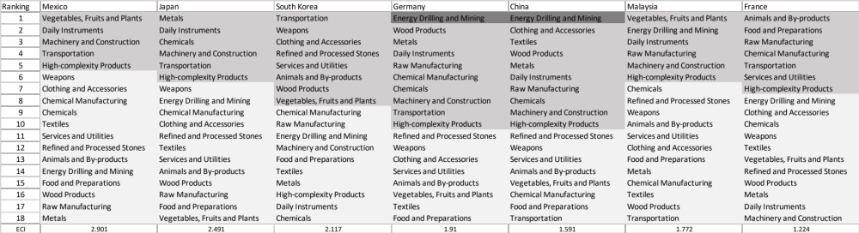

Table 5: SDV of High E_{f}CI Countries 2014

We define the ranking of opportunity gain for a country c, as the Suggested Development Vector (SDV) of c. Table 5 shows the SDV of a selected group of leading economies with outstanding economic complexity, with the industry groups ranked in decreasing order of significance. Dark grey indicates positive opportunity gain, gray indicates zero opportunity gains, and light grey indicates negative opportunity gains. The result shows that leading countries barely have any industries with positive opportunity gain. In other words, those countries are already in the most stable and efficient economic structure. Without the necessity of economic transition, those countries merely need to maintain a steady and balanced economic development. In contrast, countries listed in Table 6 have nearly half of industries with positive opportunity gain. While the economies with absolute negative E_{f}CI, such as Nigeria and Algeria, all need to develop High-complexity Products, Machinery and Construction and daily instruments, those with median E_{f}CI are facing a more complicated and diverse situation, such as Italy, Spain and the United States.

It can be concluded that Japan is categorized to be a highly complexed country as compared with the world’s leading economies and other major economies in Europe.



Table 6: SDV of Other Typical Countries 2014

4.2 Sensitivity Analysis and Contingency Strategy
Japan has a characteristic SDV of high-complexity economy and is embedded with massive production knowledge. Japan should take precautions against unexpected strikes industry by industry and forecast the adverse effects. The regression of an industry with low PCI and low Opportunity Gain is less dangerous than that of cornerstone industries. High-complexity Products is such a representative of the cornerstone industries, because High-complexity Products connects to most of the profitable products that developed countries are currently specializing in. For the same token, Food and Preparations is one of the less fundamental industries for developed countries. Such intuition can be rigorously proved by the sensitivity analysis we are about to implement.

The sensitivity analysis aims to approximate the volatility of SDV subject to an instant increment or decrement of export and is mainly implemented on developed countries that have few industries with positive opportunity gains. To be more specific, sensitivity score is the least-squared slope for the linear regression between percentage change of production for
Country C and Product P and the E _{f} CI of C.

When the opportunity gain of the industry is negative, the sensitivity analysis approximates how an over-development of the industry jeopardizes the economic structure of a country. When the opportunity gain of the industry is zero, the sensitivity analysis determines whether the further development of the industry shapes the country a better economic structure, and predicts how the SDV would change accordingly. Specifically, as we reduce the export of such an industry to 25%-50% of its original value, a few other industries originally with negative opportunity gain would probably become profitable. We separate the increment and decrement of production in the sensitivity analysis, because they tend to show vast difference. The considerable profitability of a production spike doesn’t imply a shrink is always followed by a painful crisis.

We perform the sensitivity analysis of the aggregate of top ECI countries, including US, UK, Korea, Japan, South Korea, Singapore, Germany, and France, and use the result as the benchmark. The sensitivity score in 2014 and 2009 are shown in Table 7 and Table 8 respectively:

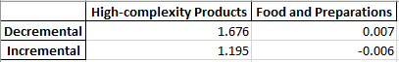

Table 7: Sensitivity Score of the Aggregate of Developed Countries 2014

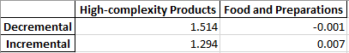

Table 8: Sensitivity Score of the Aggregate of Developed Countries 2009

In summary, High-complexity Products exerts great impacts on economics structure of top countries. Such countries are extremely vulnerable to High-complexity Products industry declines, and benefit from High-complexity Products prosperity. In contrast, ECI is not highly sensitive to shift of Food and Preparations industry.
We observe a similar pattern that the Sensitivity Score of Food and Preparations is approximately zero, while the Decremental Sensitivity Score is larger than the Increment. We can therefore make three conclusions here.
- The disturbance in Food and Preparations industry exert a trivial impact on the E_{f}CI of a country, which echoes with our intuition that Food and Preparations is of minimal significance to the structure of product space of developed countries or fast developing countries.
- The High-complexity Products industry is the cornerstone industry of most developed or fast developing countries.
- The reward of an increase of High-complexity Products production is less than the jeopardy of a decrease in the same extent.

Besides the sensitivity score, we are interested in the shift of SDV caused by upheavals in different industries. The shift of SDV gives us a good vision of how the production pattern will be affected. The results of Benchmark in 2014 are shown below in Table 9-Table 16

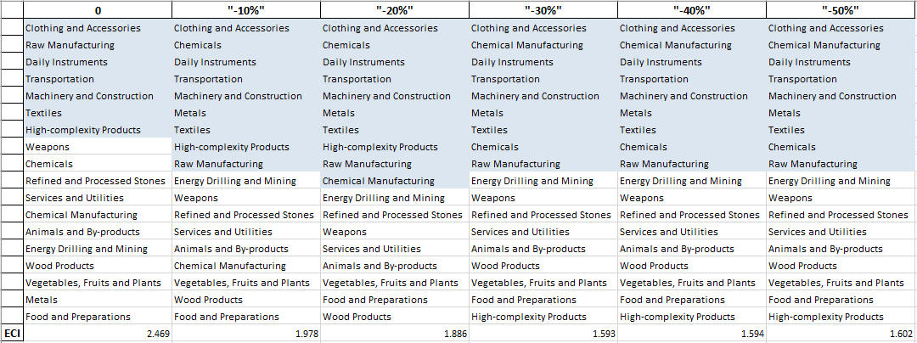
.

Table 9: Aggregated High-complexity Products 2014( Decremental Sensitivity)

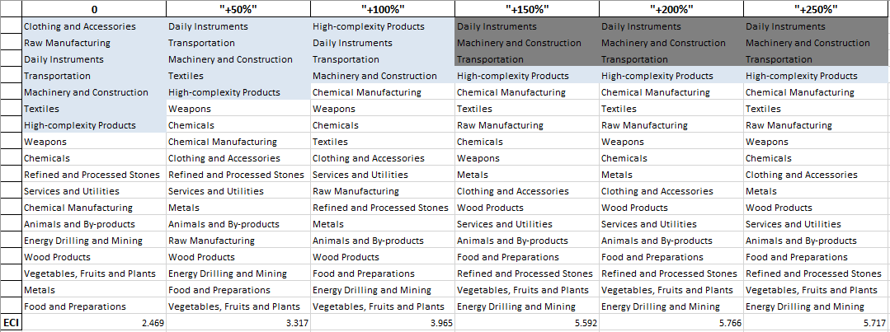

Table 10: Aggregated High-complexity Products 2014( Incremental Sensitivity)

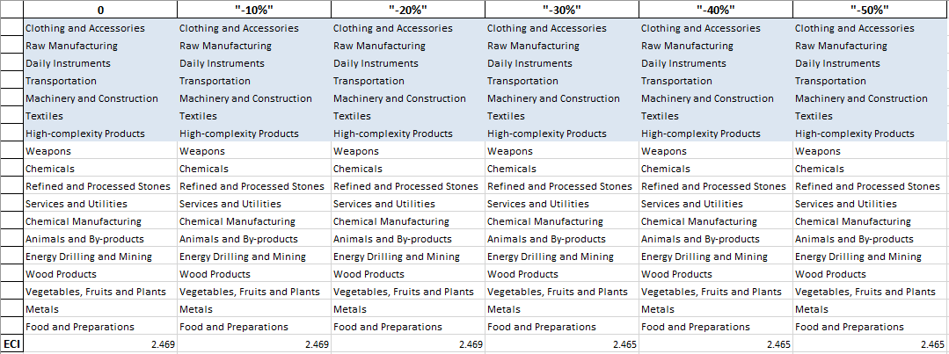

Table 11: Aggregated Food and Preparations 2014 (Decremental Sensitivity)

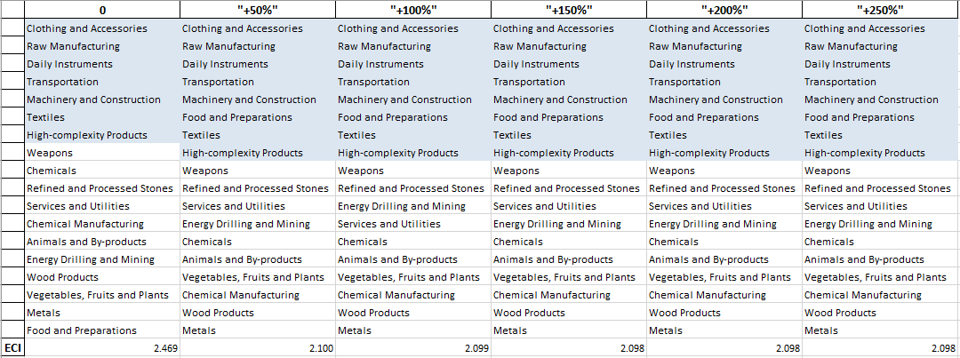

Table 12: Aggregated Food and Preparations 2014 (Incremental Sensitivity)

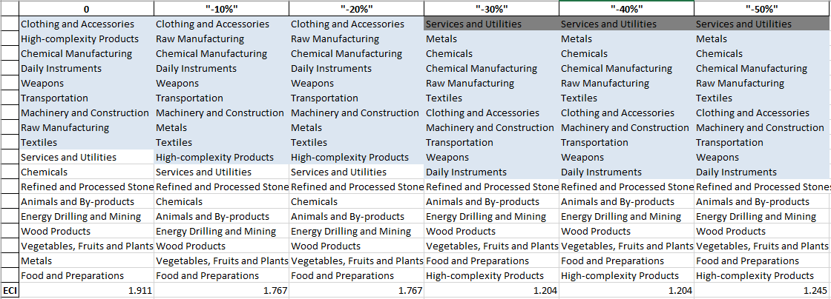

Table 13: Aggregated High-complexity Products 2009 (Decremental Sensitivity)

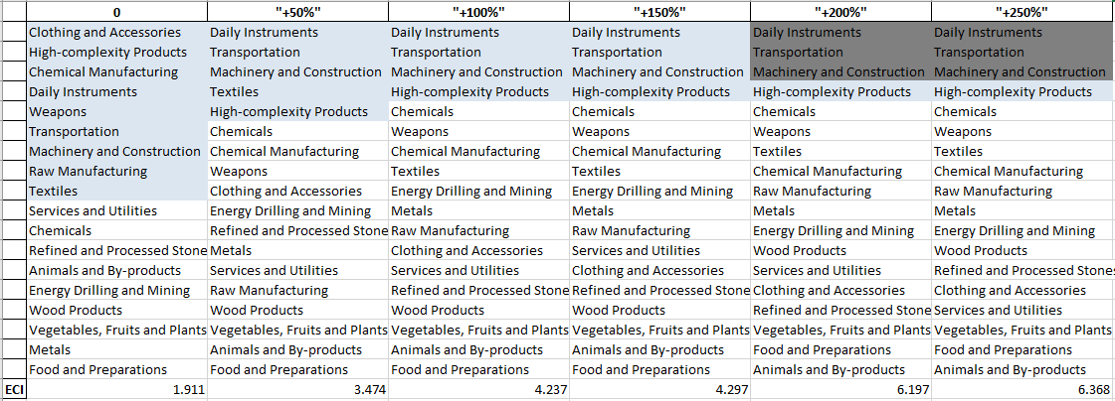

Table 14: Aggregated High-complexity Products 2009 (Incremental Sensitivity)

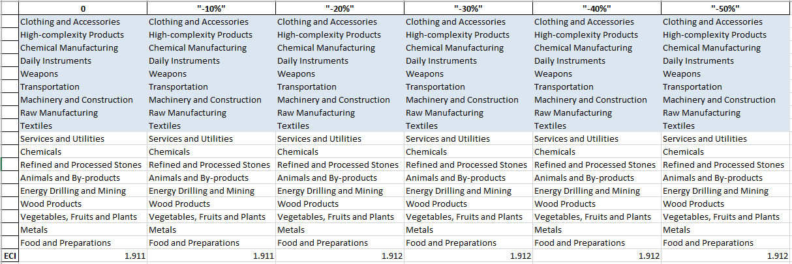

Table 15: Aggregated Food and Preparations 2009 (Decremental Sensitivity)

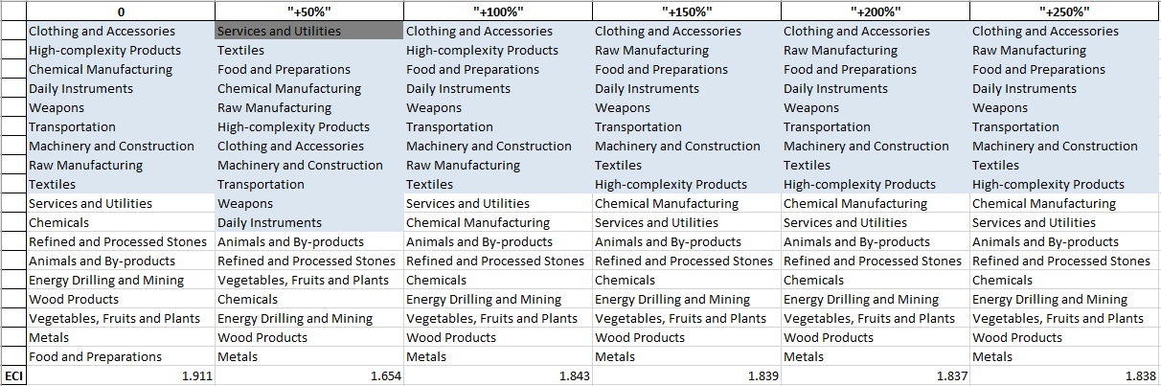

Table 16: Aggregated Food and Preparations 2009 (Incremental Sensitivity)

The Contingency Plan aims to present a set of solutions with respect to upheavals in different industries. Instead of compensating for the declining production directly, the best strategy is to develop those incipiently profitable industries. In this manner, we can derive the contingency strategy for countries to deal with possible abrupt declines of crucial industries. In some cases, the SDV remains unchanged even when a zero-opportunity-gain industry declines to its 20% in terms of export. We can then conclude the industry is not indispensable to the country. As a clarification, the three consecutive N/As means that the country doesn’t even need to respond to a collapse in the industry. Countries tend to have distinct solutions to the up and down of the same industry.

4.3 Result and interpretation
The sensitivity analysis of Japan ends up with the results below.

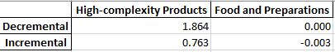

Table 17: Sensitivity Score of Japan 2014

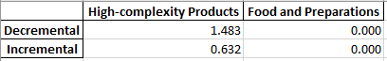

Table 18: Sensitivity Score of Japan 2009

Japan has sensitivity scores typical to developed countries. Japan is barely influenced by the flucuation in Food and Preparations industry, while is subject to the up and down in High-complexity Products. Japan’s sensitivity to High-complexity industry is obviously lower than the benchmark in 2009, but not in 2014.

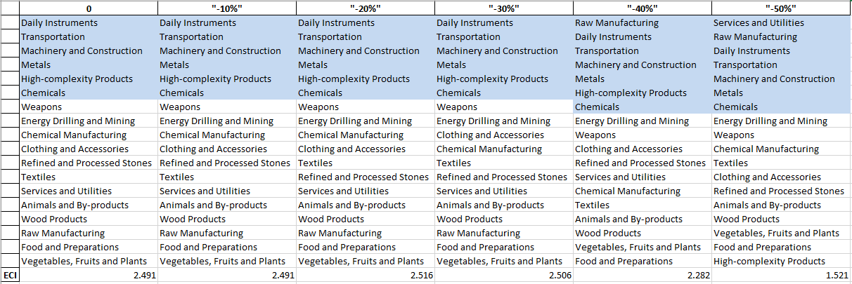

Table 19: Japan High-complexity 2014 (Decreasing Sensitivity)

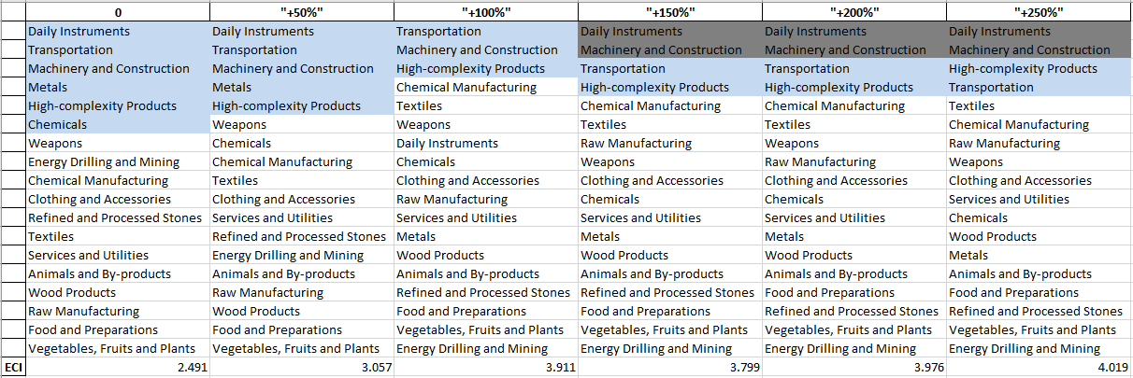

Table 20: Japan High-complexity 2014 (Incremental Sensitivity)

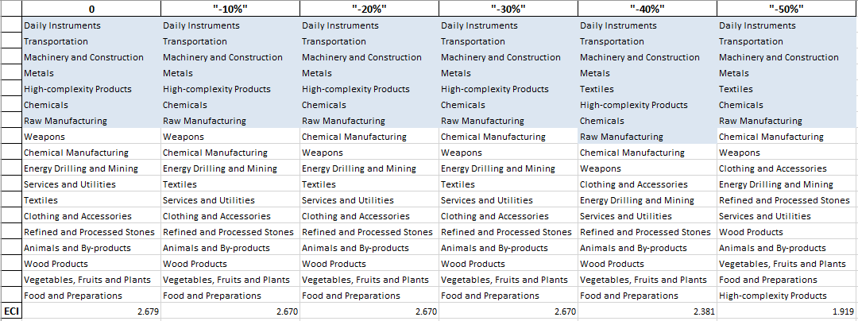

Table 21: Japan High-complexity 2009 (Decreasing Sensitivity)

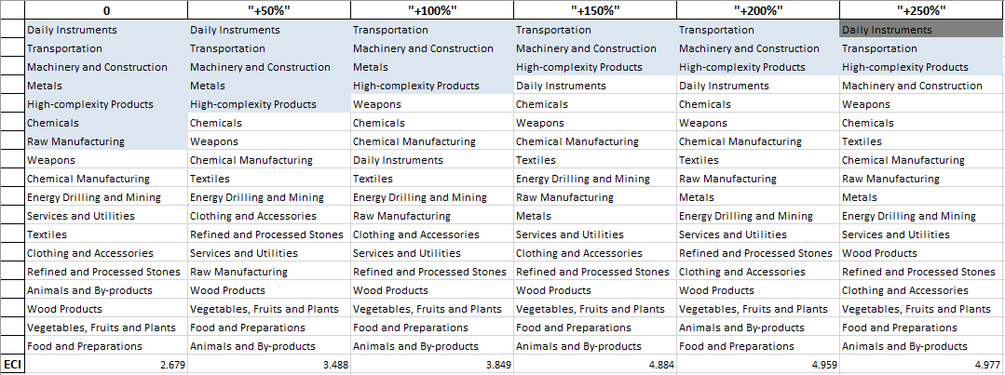

Table 22: Japan High-complexity 2009 (Incremental Sensitivity)

As shown in Table 19---Table 22 above, the economy of Japan is in a much more sensitive and fragile state in 2014, compared to 2009. If the high-complexity industry has some surprising breakthroughs, Japan would receive additional stimulations in Machinery and Construction and Daily Instruments. In 2014, a decline of high-complexity industry would make the SDV of Japan deteriorate to a great extent.

Decreasing export of each industry in Japan’s current production space by 60% respectively, we derive the contingency strategy shown below in Table 23 and 24.

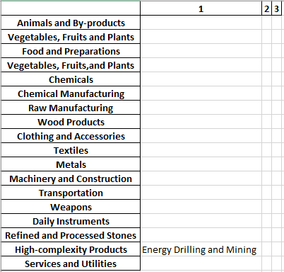

Table 23: Contingency Table of Japan during Industry Strikes 2014

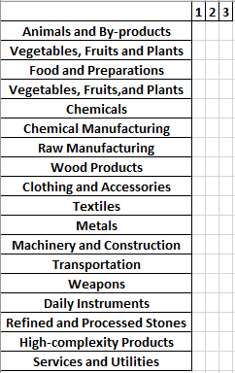

Table 24: Contingency Table of Japan during Industry Strikes 2009

Developing Energy Drilling and Mining is the solution to declines in High tech in 2014. In 2009, however, Japan a extremely stable SDV.

5. Macro-level Predictions

5.1 Structural Optimality Index
Indeed, such choice of prioritization has proven to be a significant factor in deciding the economic outcomes of countries. In order to quantitatively evaluate how effective our developmental strategies are and how deviations from the suggested developmental path will lead to non-optimal growth results, we define the measure – Structural Optimality Index (SOI) – on a country level as the R-Square obtained from regressing the country’s realized industry development over the suggested development strategy. Both strategies are quantified in nature, with the realized industry development represented by export increase in major industry groups and the suggested development strategy represented by the opportunity gains of developing the corresponding industry groups as calculated in previous sections. The R-square from the regression thus provides us with a concrete measure of how the development path adopted by the country has fitted with/differed from our suggestion.

After obtaining this measure for all countries in our database, we further regress countries’ five-year economic growth, which is defined as the net increase in GDP (USD), over their SOI. Figure 6 illustrates the regression output, which shows a strong positive correlation between countries’ SOI and their five-year GDP growth, significant at the 1% level and achieving an adjusted R² of 11.9%. In other words, the more a country develops as suggested by calculations on a complexity level, the better economic outcomes it achieves.

Statistics | Value
Multiple R | 0.355
R-Square | 0.126
Adjusted R² | 0.119
Variable | Value
Coefficient | 1.249*10¹²
t-stat | 4.061
P-value | 0.000(***)


Figure 6: Regression of Five-year GDP Growth over SOI

5.2 SOI of Japan and Its Implications
Japan, for instance, has a relatively low level of structural optimality as compared with its peers. As the regression in Figure 7 suggests (the orange curve represents export increase and the blue curve stands for opportunity gain of the corresponding industry), Japan demonstrates a moderate level of correlation with the suggested developmental path, having an adjusted R-square of around 58.3% and an annual growth rate of -1.5%. This is in direct contrast to emerging economies such as China, where there is high SOI of around 82.8% and a corresponding GDP growth of 5.39 billion USD, making it one of the fastest developing economies during the period. In sum, Japan’s stagnant economic progress from 2009 to 2014 can be at least partially explained by a mismatched development strategy that demonstrates a considerable level of deviations from our suggested developmental path. In specific, Japan invested heavily in the High-complexity Products industry, while it should have focused more on industry groups such as Machinery and Construction and Services and Utilities.


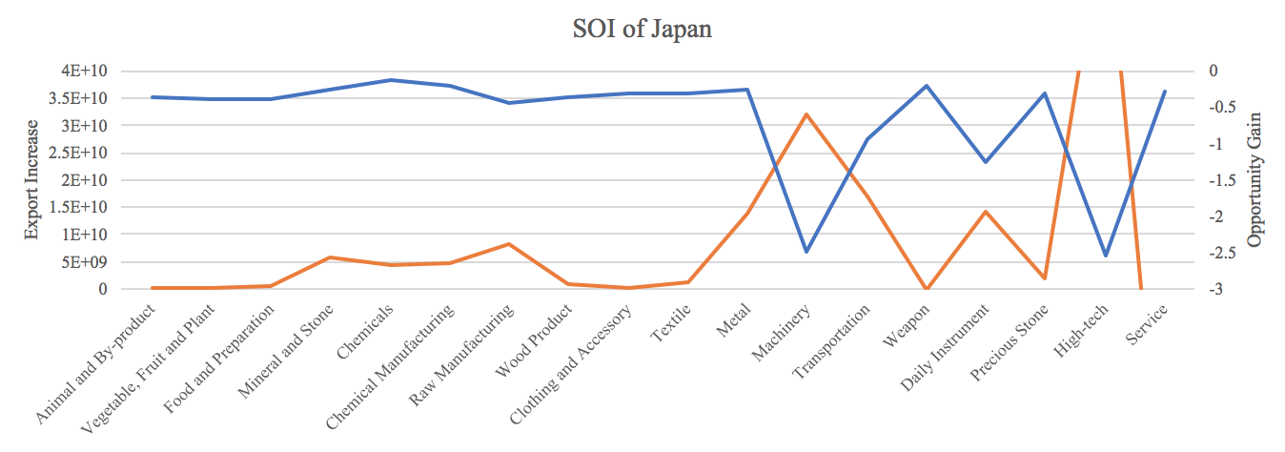

Figure 7: SOI of Japan (2009-2014)

6. Concluding Remarks

In conclusion, Japan has demonstrated a particularly low level of economic growth in terms of GDP during the period from 2009 to 2014, concurrent with a stagnation in economic complexity as compared with other major Asian or developed economies in the world.

The lack of economic progress during the period, we believe, can be partially explained through analysis of the economic and product complexity structure of Japan on the industry group level. The product classification system we adopt allows us to measure the realized industry development for various industry groups and to observe that Japan aggressively invested in High-complexity Products, Machinery and Construction and transportation industry groups during the period, while its developed peers and emerging economies around the globe have adopted a slightly more conservative growth path.

Based on our analysis of the opportunity gain and a sensitivity analysis of major industry groups, Japan can further its gains by staying optimal with its current industry structure and there is no immediate need of reform because no industry has a positive opportunity gain at its current stage. We further note that Japan has a slightly mismatched development strategy that indicates a moderate level of structural optimality on the complexity level, having an adjusted R-square of around 58.3%. Since a significant positive correlation exists between five-year GDP growth and the structural optimality index of an economy as we define and calculate, Japan indeed has a suboptimal growth experience as compared with fast-growing economies both on a regional scale and on a global scale, and has the potential to further its economic gains through industrial structure balancing as suggested in the paper.

References

Hausmann, R., Hidalgo, C., Bustos, S., Coscia, M., Chung, S., Jimenez, J., Simoes, A. and Yıldırım, M. (2007). The Atlas of Economic Complexity. [online] Atlas.cid.harvard.edu. Available at: http://atlas.cid.harvard.edu/.

Balassa, B., “The Purchasing Power Parity Doctrine - A Reapprais- al,” Journal of Political Economy 72, 584-596 (1964).

Feenstra, R.; Lipsey, R.; Deng, H.; Ma, A. & Mo, H. “World Trade Flows: 1962-2000” NBER working paper 11040. National Bureau of Economic Research, Cambridge MA (2005).

United Nations Commodity Trade Statistics Database (http://comtrade.un.org/db/), accessed in August 2019.

The World Economic Forum, “The global competitiveness report,” (various years).

Barro, R. & Lee, J-W. “A New Data Set of Educational Attainment in the World, 1950-2010,” NBER Working Paper No. 1590 (2010).

Kaufmann, D. & Kraay, A. “Governance Indicators: Where Are We, Where Should We Be Going?” Policy Research Working Paper 4370. Washington, DC: World Bank (2008).

Hanushek, E.A. & Woessmann, L. “The Role of Cognitive Skills in Economic Development,” Journal of Economic Literature 46(3), 607- 668 (2008).

